Thermal Management and CFD Analysis of EV Battery Pack

Submitted by- Preetesh Suna, Jr. Drivetrain Engineer, Team Roadrunner, SAE NITR

Objective: To evaluate thermal behavior of a lithium-ion battery pack under load using CFD and validate cooling effectiveness.

Methodology:
- Heat generation calculated using Joule heating (I²R)
- CFD simulation performed in ANSYS Fluent
- Forced air cooling applied using velocity inlet boundary condition

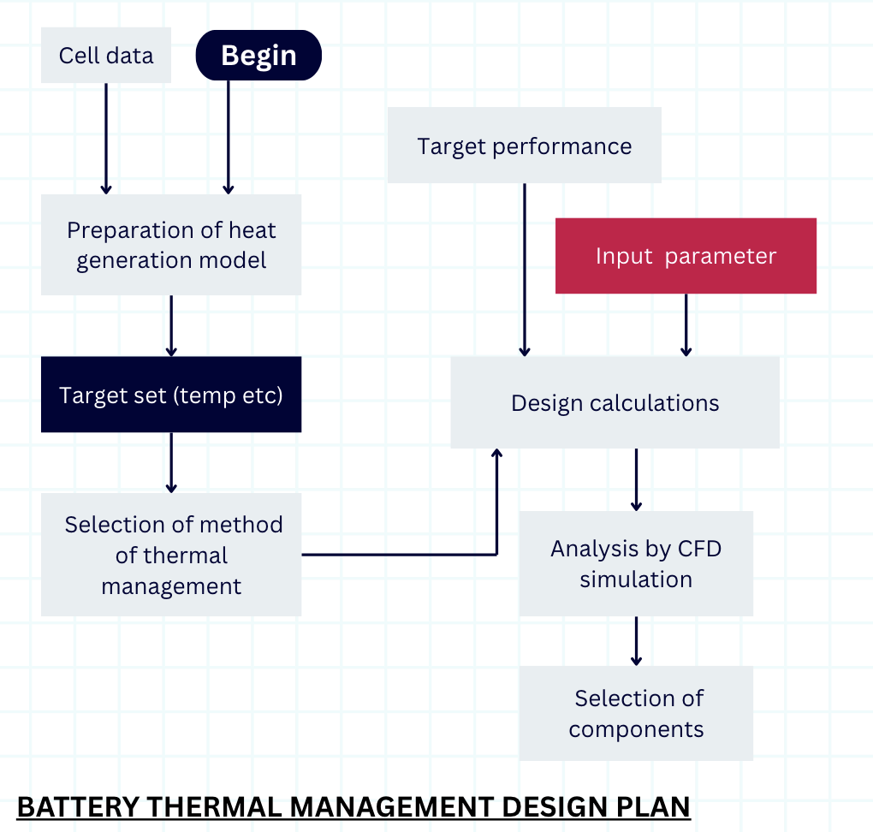

The following table is a datasheet for the Lithium-ion rechargeable battery used for our battery pack.

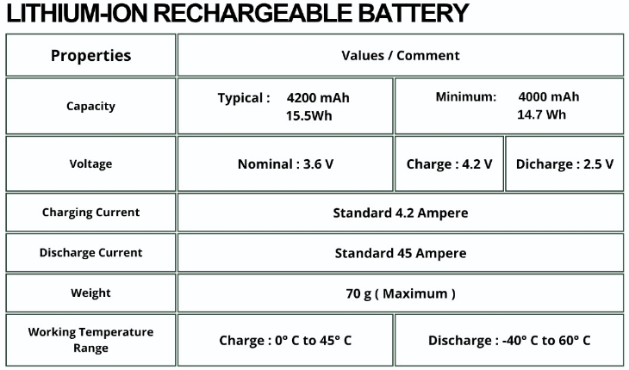

Cell Module Configuration:
Configuration: 18p20s
Cell holder material : EABS (UL94VO) fire resistant
Cell connections: Nickel Strips(0.3x5mm), Spot Welding
Module Connections: Busbars, Maintenance Plugs and Cables
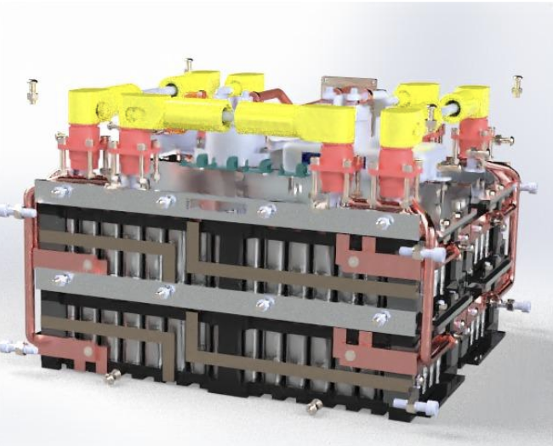
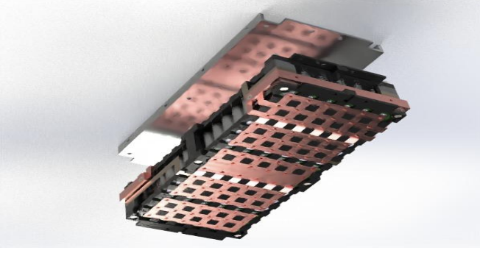

CFD Simulations in ANSYS:

The following is the calculated data done in an Excel sheet for our battery pack.

Heat Generation Calculations
Total Number of cells in Battery Pack | 360
number of cells in a module | 90
current per cell(A) | 13.89
voltage(V) | 4.2
internal resistance(ohm) | 0.016
heat gen. per cell(W) | 3.0869136
heat gen. for pack(W) | 277.822224
diameter of cell(m) | 0.0217
height(m) | 0.0702
CSA(m^2) per cell | 0.004785713753
volume(m^3) per cell | 0.00002596249711
heat source(W/(m^3)) | 118898.9482
Maximum Temp . of Cell (*C) | 35.048
Tcell(K) | 308.048
Tamb(K) | 300
temp difference(K) | 8.048
thermal resistance(K/W) | 0.02896816491
convective HTC(W/cm^2K) | 0.008014746449

Observation: Temperature contours indicate hotspot concentration at central cells, while forced convection maintains safe thermal limits.
- The maximum cell temperature reached 36.08 °C, well within the safe operating limit.
- The module was cooled using a blower-based active cooling system.
- ANSYS Static Thermal and Fluent CFD analyses were performed to validate the maximum temperature generated in the cell.
- Accumulator with 3 blowers on each side Fan Mount
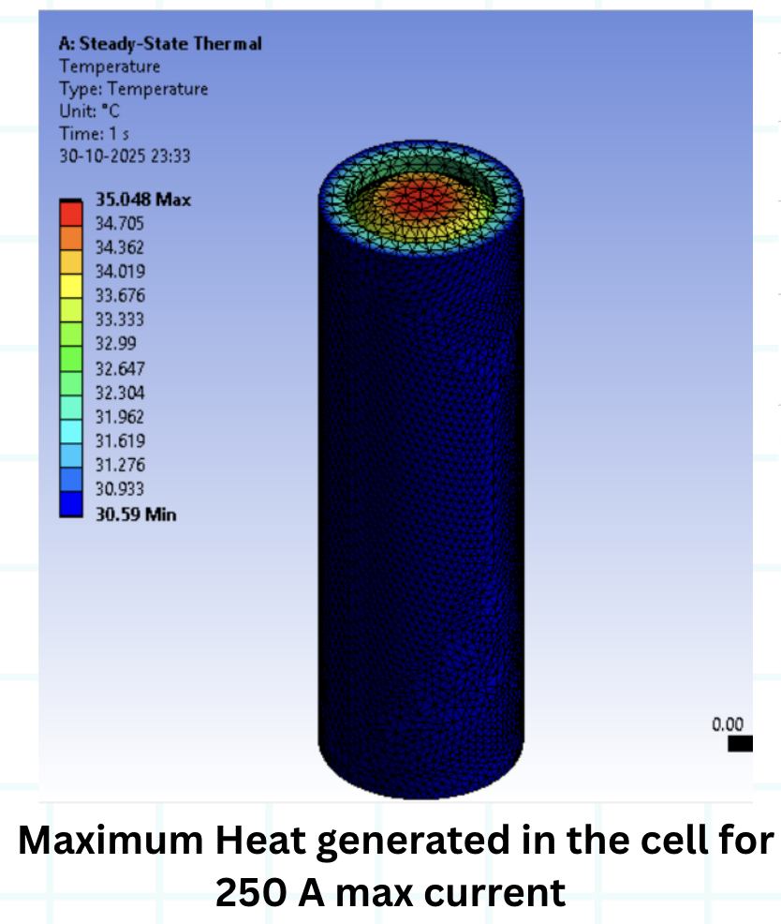
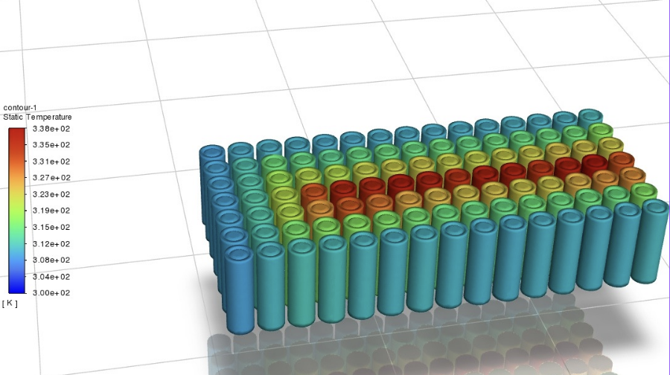

Test, Tune & Validation:
- The module contains 90 cells arranged in 6 rows × 15 columns with an 18p5s configuration (18 cells in parallel, 5 groups in series) to balance capacity and voltage.
- Cells are housed in 3D-printed holders made of Bambu PC FR, a strong and fire-retardant polycarbonate ensuring safety and precise alignment.
- Copper busbars provide electrical connections: 1.5 mm thick over cells for parallel distribution and 3 mm thick for main current draw, minimizing resistance and heating.
- The design emphasizes safety, efficiency, and reliability, with optimized current paths, reduced hotspots, and robust mechanical stability.
The Saietta 119R motor (Motor used in our EV vehicle) was integrated with a motor controller and powered using a lithium-ion battery pack. The motor controller was connected to the Accelerator Pedal Position Sensor (APPS), which provided input signals for actuation. During testing, the motor responded effectively to pedal input: the RPM increased progressively as the pedal was pressed and decreased correspondingly when the pedal was released. This confirmed proper communication between the APPS, motor controller, and motor, validating the control system functionality and responsiveness under load conditions.

Results & Discussion:
The simulation results indicate that the battery pack operates within safe thermal limits. The maximum cell temperature remains below critical thresholds, and temperature rise is limited to ~8K. Forced air cooling effectively reduces hotspot formation and maintains uniform temperature distribution.

Conclusion:
The study demonstrates that the designed air cooling system is sufficient for maintaining thermal safety of the battery pack. The approach can be extended for optimization of cooling strategies in EV applications.

